**Module-6: Ansible Assignment - 3**

You have been asked to:

● Create 2 Ansible Roles

● Install apache2 on slave1 using one role and nginx on slave2 using the other role

Above should be implemented using different Ansible Roles

**support@**

Create role and add tasks

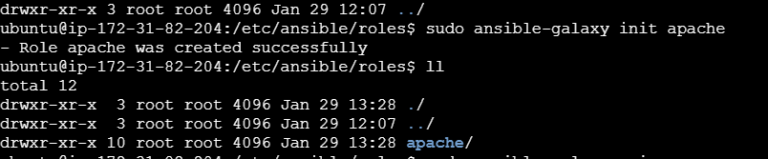

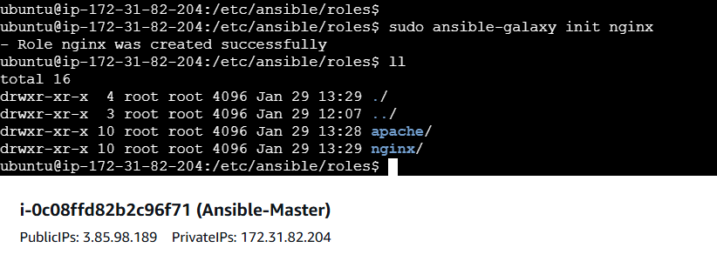

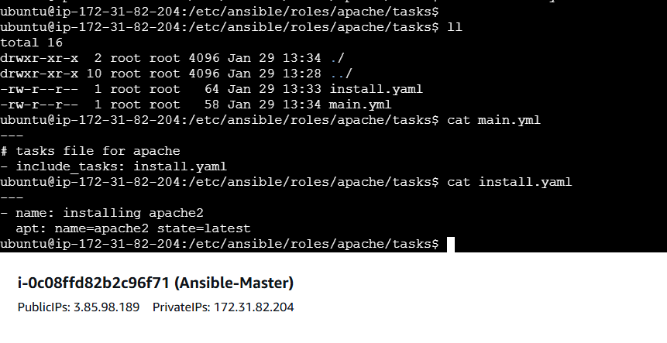

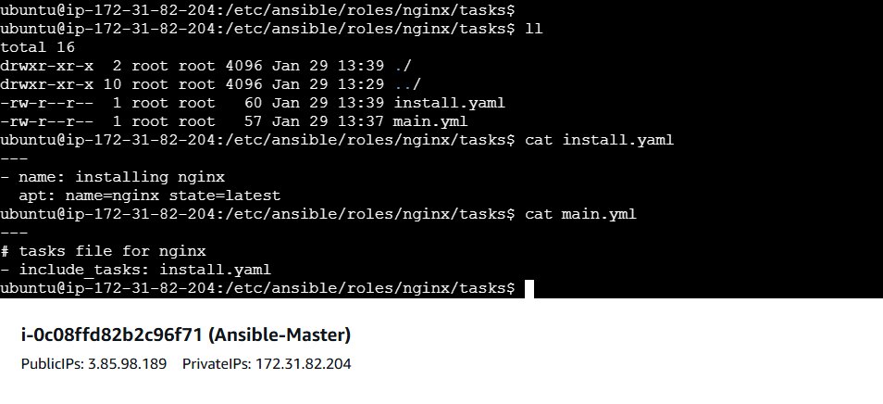

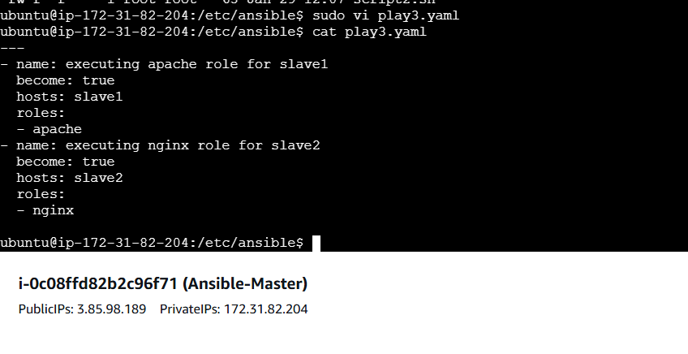

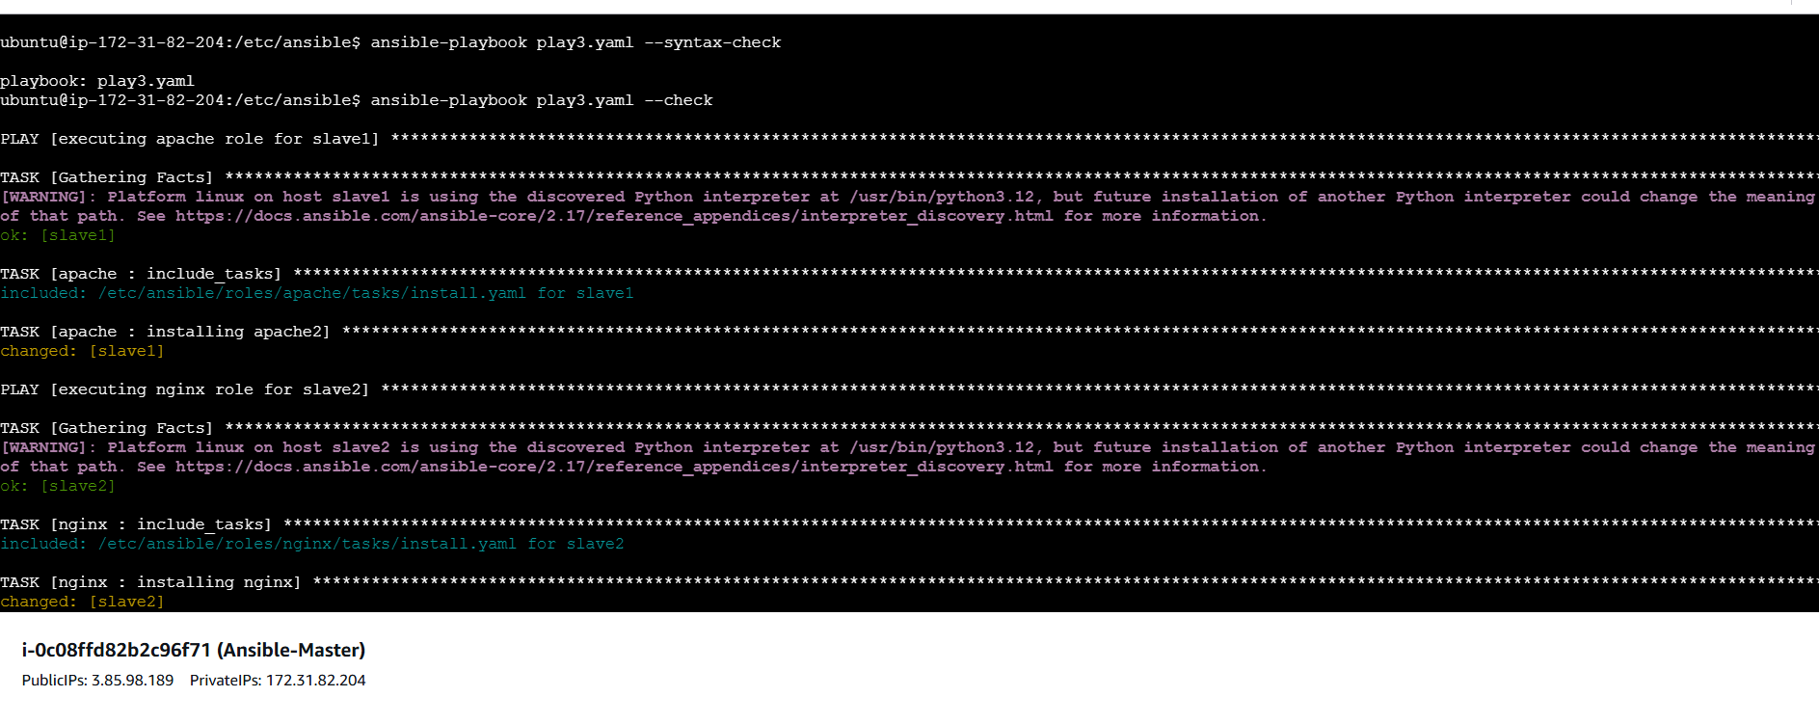

And run the playbook

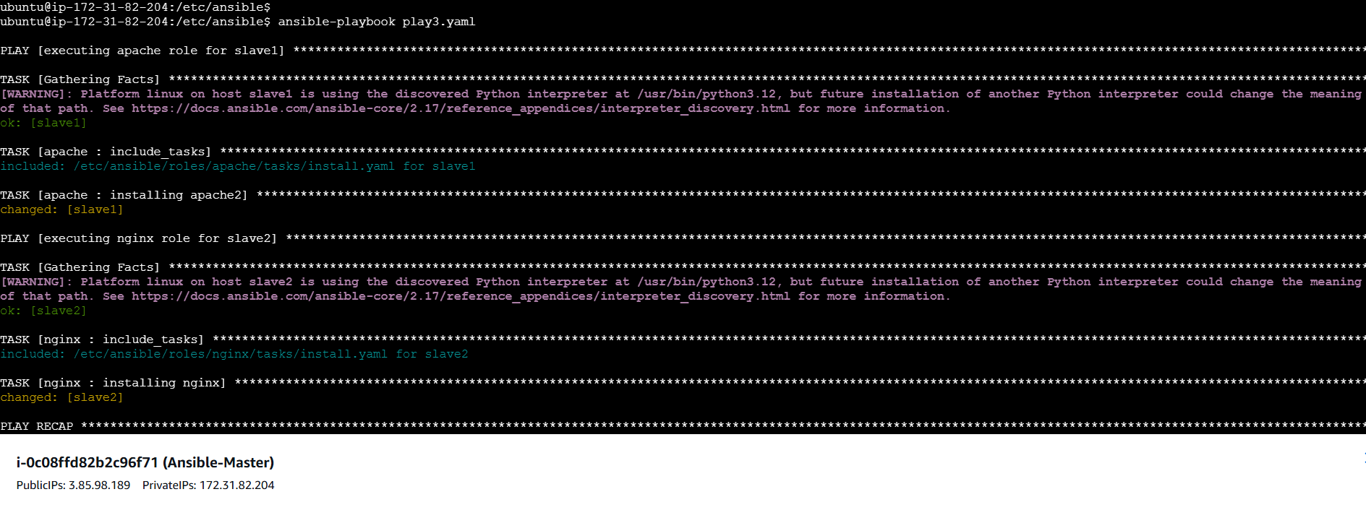

Now verify apache2 installed on slave1

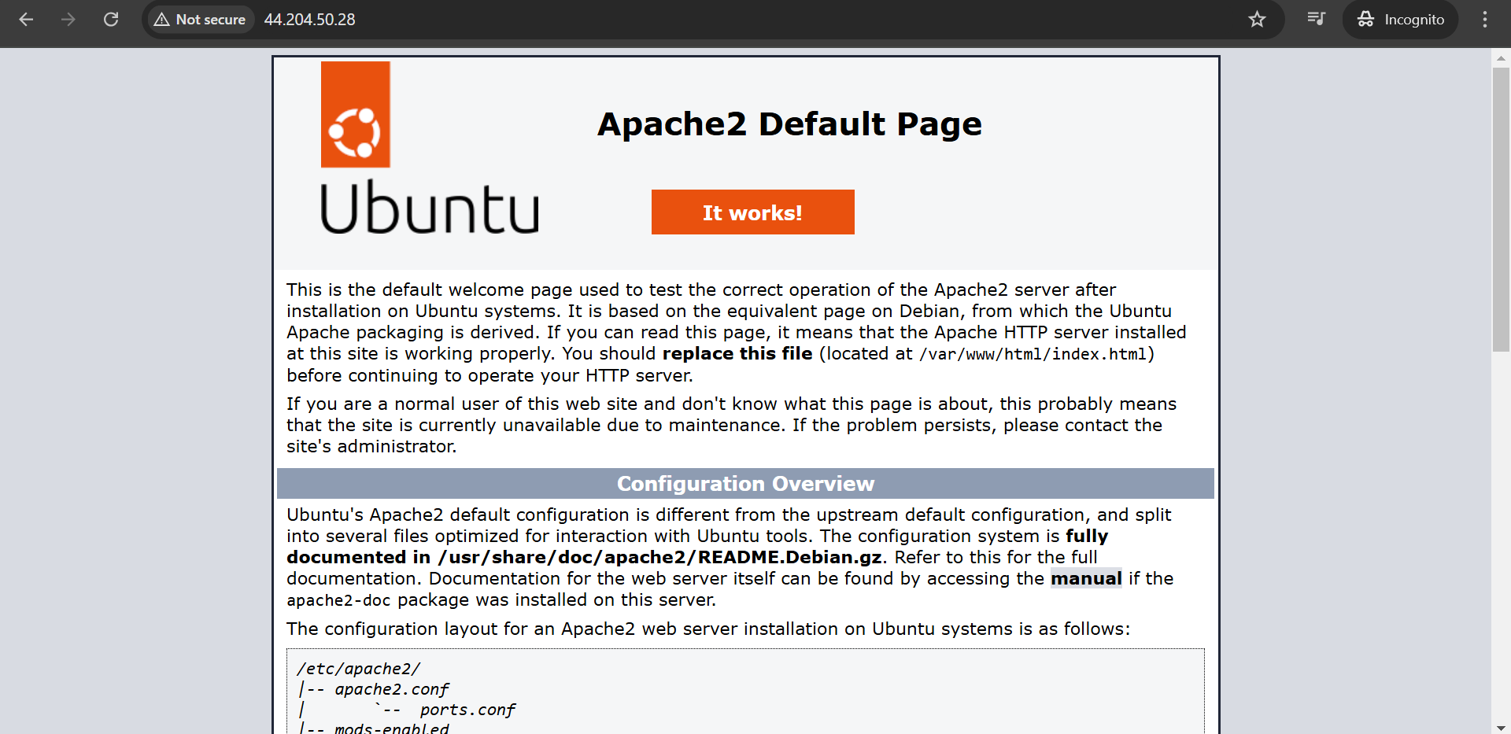

Nginx installed on slave2

